2019 Electronic Messaging
Back-to-School Eye Exams

Use the content below for your practice website, patient newsletters/e-mails, or on your social media channels.

- Back to school message:

Remember to schedule your child’s back to school comprehensive eye exam early. September brings a rush of students scheduling appointments and wanting to achieve their best academic work, which means they need to see well. Your child’s eye exam should be part of any back to school checklist.

- Back to School Check list: Use this infographic on your Web site or social media channels:

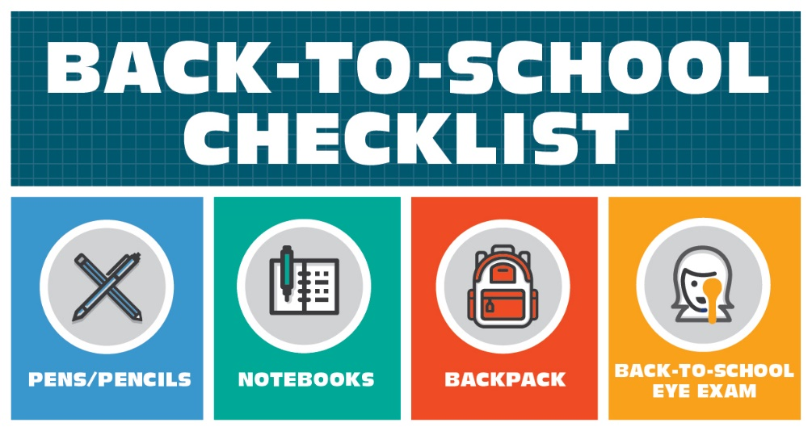

- Vision facts to include on your Facebook page:

Much of a child’s learning is visual. How well can your child see? If you don't know, it's time for a comprehensive eye exam.

------

Blurry vision is not the only reason to have an eye exam. Your child could have difficulty using both eyes together, a critical reading skill, and you might not know. Back to school means it's time to get a comprehensive eye exam.

------

Undetected and untreated vision problems can elicit some of the very same signs and symptoms commonly attributed to ADHD. A yearly comprehensive eye exam can help make the right diagnosis for your child’s needs.
(Source: https://www.aoa.org/patients-and-public/good-vision-throughout-life/childrens-vision/school-aged-vision-6-to-18-years-of-age)

Content provided by the American Optometric Association Health Promotion Committee

Additional patient education brochures can be purchased through the AOA Marketplace.

