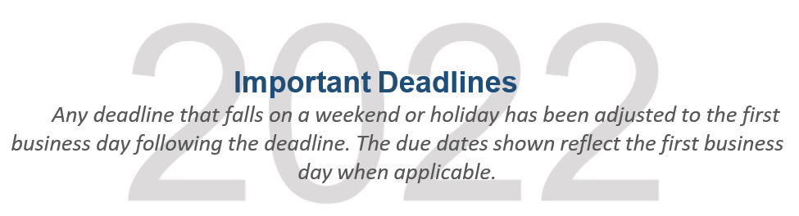

January………………………………………………………………….
4 Open enrollment period for change in classification begins for 2022.
4 Fourth quarter 2021 dues payment due.
14 Fourth quarter 2021 preliminary delinquent reports issued.

February……………………………………………………………….
1 Members considered delinquent for fourth quarter 2021, if required dues payment has not been made.
15 Response due for AOA annual audit membership confirmation from BKD, LLP, if selected for the confirmation process.
15 Fourth quarter 2021 final delinquent reports issued.
28 Members eligible for suspension for fourth quarter 2021, if required dues payment has not been made.

March…………………………………………………………………….
1 Fourth quarter 2021 suspend process completed and reports issued.
1 First quarter 2022 dues remittance issued.
31 First quarter 2022 dues payment due.

April…...……………………………………………………………….
- 2022 credentialing process begins.

May……………………………………………………………………….
- Members considered delinquent for first quarter 2022, if required dues payment has not been made.
2 End of open enrollment period for change in classification. Changes received after this date cannot be processed for current year.
2 Deceased Member Tribute corrections/updates due.
2 House of Delegates credentialing deadline. All payments and membership transactions must be received by 5 p.m. (CST) to be included in the credentialing process. A May 2 postmark is not considered as having met the credentialing deadline.
16 First quarter 2022 final notice delinquent reports issued.

May……………………………………………………………………….

31 Final credentialing delegate and vote counts issued.
31 Members eligible for suspension for first quarter 2022, if required dues payment has not been made.

June...……………………………………………………………………
1 First quarter 2022 suspend process completed and reports issued.
1 Second quarter 2022 dues remittance issued.
10 Credentialing Certification and Notification of Delegates Form due.
30 Second quarter 2022 dues payment due.

July...……………………………………………………………………
15 Second quarter 2022 preliminary delinquent reports issued.

August….………………………………………………………………
1 Members considered delinquent for second quarter 2022, if required dues payment has not been made.
15 Second quarter 2022 final notice delinquent reports issued.
31 Members eligible for suspension for second quarter 2022, if required dues payment has not been made.

September………………………………………………………………
1 Second quarter 2022 suspend process completed and reports issued.
1 Third quarter 2022 dues remittance issued.
30 Third quarter 2022 dues payment due.

October…………………………………………………………………
17 Third quarter 2022 preliminary delinquent reports issued.
28 Dues increase for 2023, if any, and lobbying percentage of dues deductibility is announced.
31 Members considered delinquent for third quarter 2022, if required dues payment has not been made.

November………………………………………………………………
15 Lobbying percentage of dues deductibility is announced.
15 Third quarter 2022 final notice delinquent reports issued.
30 Members eligible for suspension for third quarter 2022, if required dues payment has not been made.

December………………………………………………………………
1 Third quarter 2022 suspend process completed and reports issued.
1 Fourth quarter 2022 dues remittance issued.
31 2022 renewal of dues are processed, and renewal reports issued.
31 Fourth quarter 2022 dues payment due (with holiday actual due date is Jan. 3, 2023).

